**ENGLISH 110**

Semester: Fall 2024

Course #: ENG 110

Days/Time: in-person every Monday 12:30 - 1:45 pm | Wednesday 12:30 - 1:45 pm

Location: NAC 6/306

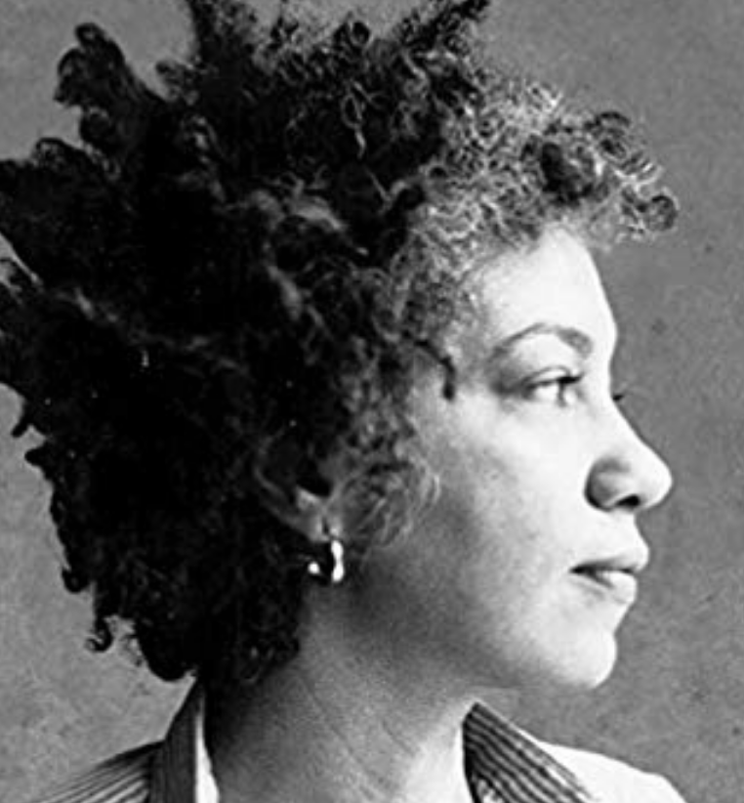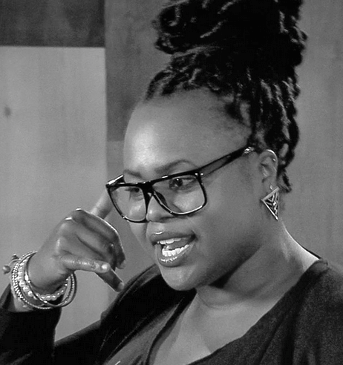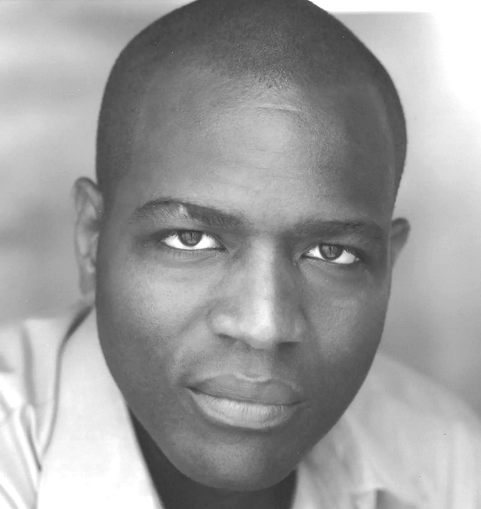

**Table of contents**

instructor contact info 2

course description 2

topic of inquiry 2

texts & materials required 3

technology & software required 3

learning outcomes 3

major assignments & due dates 4

grading & attendance agreement snapshot 4

policies & procedures 5

# instructor contact info

Name: Irina (Ira) Fastovets

Email: [englishwithirine@gmail.com](mailto:englishwithirine@gmail.com) [ifastovets@ccny.cuny.edu](mailto:ifastovets@ccny.cuny.edu)

Office: 6/339

Office Hours: Office Hours: Monday 11:00 - 12:00 pm | Wednesday 11:00 - 12:00 pm

Zoom: [click here](https://ccny.zoom.us/j/3674154056?pwd=BERzJ1Srz3N1zN8UQw6pIBaUURi3ed.1) or login: 367 415 4056/ key: 721173

# course description

Welcome to your first-year composition (writing) course! This class is all about you practicing reading and writing for different contexts. You’ll learn strategies for analyzing different writing situations and then practice meeting (or purposely defying) expectations for those situations. You’ll thus study rhetoric (the art of communication) and practice writing across genres and for different purposes and audiences. You’ll also receive substantial feedback on your writing, provide extensive feedback on others’ writing, and get lots of practice revising and editing based on feedback received. As learning from each other will be a large part of what we do, you are expected to be an active participant in the classroom community.

# 

# topic of inquiry

For the purposes of building our critical reading and thinking practices, we will engage several readings on a shared course topic of inquiry:

**“The Politics of Language.”**

We can understand this course as drawing on the topic of language and literacy as a vehicle for critically analyzing *and* *developing* our own languages and literacies.

We will explore questions such as these:

* What is the relationship between language, race, and power?
* How do attitudes about language standards empower and oppress language users?
* What are the historical and political implications behind how “Standard English” is valued and traditionally approached?
* How are we—the readers and writers participating in this class—affected by the ways that language and literacy function in the U.S.? That is, how do our language backgrounds affect our lived experiences and how we are perceived and treated by others?

# texts & materials required

**This is a “ZERO Textbook Cost” course. As such, all materials will be accessible for free online.**

We will also read a collection of student writing (yours, your peers’, and others’). Please have access to all course documents and materials for class.

**Recommended Open Education Resources**

For help with the writing, editing, and formatting:

[Norton Field Guide](https://www.wwnorton.com/college/english/write/fieldguide/index.asp)

[Lumen Learning](https://courses.lumenlearning.com/englishcomp1v2xmaster/)

[Writing Commons](https://writingcommons.org/)

[Online Writing Lab (OWL)](https://owl.english.purdue.edu/owl/)

[UNC Writing Center Tips and Tools](https://writingcenter.unc.edu/tips-and-tools/)

# technology & software required

You will need to regularly access

1. [Slack](https://join.slack.com/shareDM/zt-2oiowz82b-BRnbswu1kcppw34mTCW9oQ) (an App you’ll download onto your mobile device, which we’ll use for day-to-day communications)
2. [Google Classroom](https://classroom.google.com/c/NzAyOTU5OTg3NzA1?cjc=zixqy42) (a free online space where you’ll submit assignments and collaborate on writing)
3. Word-processing software of your choice: Microsoft Office, [Office365](https://www.ccny.cuny.edu/it/microsoft-office-365-students) (available for free to CCNY students), Google Docs, etc.

# learning outcomes

In this course, you will

1. Examine how **attitudes towards linguistic standards** empower and oppress language users.
2. Explore and analyze, in writing and reading, a **variety of genres and rhetorical situations**.
3. Develop **strategies** for reading, drafting, collaborating, revising, and editing.
4. Recognize and practice **key rhetorical terms and strategies** when engaged in writing situations.
5. Understand and use **print and digital technologies** to address a range of audiences.
6. Locate **research sources** (including academic journal articles, magazine and newspaper articles) in the library’s databases or archives and on the Internet and evaluate and then work for credibility, accuracy, timeliness, and bias.
7. Compose **texts that integrate a stance** with appropriate sources, using strategies such as summary, analysis, synthesis, and argumentation.
8. Practice systematic application of **MLA 9 Style** **citation conventions**

# major assignments & due dates

You will complete three major writing assignments. Assignment prompts with more detail will be provided.

All major assignments must be successfully completed in order to pass this course.

|  |  |  |  |  |  |
| --- | --- | --- | --- | --- | --- |
| **#** | **Assignment Name** | **Page Length** | **Full**  **Draft Due** | **Final**  **Draft Due** | **Portfolio**  **Draft Due** |
| **1** | Language & Literacy Narrative | 2.5-3 pages | 9/16 | 9/18 | 10/4 |
| Translation 1: Spoken Narrative | 3 minutes | 9/23 | 9/25 | N/A |
| **2** | Synthesis Essay | 5-7 pages | 11/11 | 11/13 | 12/2 |
| Translation 2: Visual Argument | Varies | 11/18 | 11/25 | 12/2 |
| **3** | Final Self-Assessment Essay | 3-4 pages | 12/9 | 12/11 | 12/18 |
| Final Portfolio | Varies | N/A | 12/18 | N/A |
| **X** | Self-Assessments (x5) | 1.5-2 pgs. | #1-2: 10/7 | #3:11/18 | #4:12/2 | | |

# grading & attendance agreement snapshot

We will use a Grading Agreement for this course (see agreement doc for details). In short, your grade will be based on your attendance, as well as your timely and successful completion of all major and minor assignments.

|  |  |  |  |  |  |  |
| --- | --- | --- | --- | --- | --- | --- |
|  | **# of Absences** | **# of Missed Major Assigns.** | **# of Missed HW Assigns.** | **# of Missed /Late Drafts**  **(12 total)** | **# of Missed Peer Reviews**  **(8 total)** | **# of Missed Labor Logs**  **(13 total)** |
| **A+** | 3 | 0 | 0 | 0 | 0 | 3 |
| **A** | 3 | 0 | 1 | 1 | 1 | 3 |
| **A-** | 3 | 0 | 2 | 2 | 2 | 3 |
| **B** | 4 | 0 | 3 | 3 | 3 | 4 |
| **C** | 5 | 0 | 4 | 4 | 4 | 5 |
| **D** | 6 | 0 | 5 | 5 | 5 | 6 |
| **F** | 7 or more | 1 or more | 6 or more | 6 or more | 6 or more | 7 or more |

# policies & procedures

**Homework (HW) Assignments:**

* **What**: Reading and writing HW assignments will be due before almost every class. You will be asked to read, annotate, take reading notes, jot down ideas, revisit in-class assignments, collaborate (online) with your classmates, and engage in a variety of research, writing, and revision assignments.
* **When**: Most HW is due 30 minutes before our class starts (so MW by 12:00 pm). HW due at other times will be announced.
* **How much**: You should plan to spend about: 4-8 hours on homework and/or essay writing for this course each week.
* **Why:** The more reading and writing practice we get, the better readers and writers we become.Much of your grade depends on you submitting smaller homework assignments, so do take these assignments seriously. I (your instructor) will review homework on a regular basis.

**Submitting Assignments:**

1. All assignments will be submitted online on our [Google Classroom](https://classroom.google.com/c/NzAyOTU5OTg3NzA1?cjc=zixqy42) site.
2. Save all documents as .docx files.
3. Save documents as follows: *Last name_First name_Assignment Title_Phase_Week*
4. Do **NOT** submit inks, PDFs, or Pages files.

**Hot tips:**

* Save your work often! Computers are susceptible to crashing. Save your work frequently and back up your files.
* Organize your work! Create an “English 110” folder on your computer, use subfolders, and title documents. You will need to return to assignments regularly.

**Contacting Your Instructor:** I want to get to know you, and I care about supporting your learning. Do not hesitate to visit during office hours (or make an appointment). Please keep me informed about your work, your progress, and your problems, preferably BEFORE your grade is the central concern. Feel free to email me questions or send important reminders.

**Professional Courtesy:** It’s essential that we are all courteous and considerate of each other at all times. As a group, we will represent diverse cultural, racial, linguistic, and gendered identities and abilities. We must all commit to honoring, respecting, and accounting for our differences. As your instructor, I am committed to this.

**Drafting & Feedback**: You will write multiple drafts and revise each major assignment based on peer feedback. You will also receive extensive instructor feedback on your “Final” draft, which you will substantially revise again for your Portfolio.

**Technology Expectations**: I ask that you please turn off all electronic devices that are not to be used during class time. We will sometimes rely on our cell phones, laptops, or university desktop computers (located in library computer labs). You are tasked with accessing and submitting documents online. Learning about and regularly accessing technology is a critical part of our course.

**Participation:** I care deeply about students being present and engaged in class, and I’ll do my best to make class meetings meaningful and useful. I ask that you come to class on time and prepared with all relevant readings or texts. Everyone has different approaches to participation, so I welcome you to engage in class in a way that best fits you (by quietly but actively listening, writing in the chat, taking notes, asking questions, and/or offering comments). Everyone is required, however, to collaborate with peers during group work.

**Language**: Students are expected to take an active role in developing their writing and language. I recognize that students come from different educational, linguistic, and racial backgrounds and that it takes several years, not a semester, to develop English academic language, especially if English is a student’s additional (and not first) language. As your instructor, I am committed to adopting approaches deemed most effective by the fields of Second Language Writing and Composition and Rhetoric: I will provide ongoing feedback on your writing to highlight potential areas to revise/develop (including language uses), and I will refrain from penalizing you for your language. You will also learn in this course about the racial politics of using language as a tool for measuring students’ and others’ learning, qualifications, and intelligence.

**The Writing Center:** The CCNY Writing Center provides a supportive learning environment where students can have one-on-one tutoring sessions with experienced writing consultants. The Writing Center is available for virtual meetings. Students can schedule an appointment through [the writing center online appointment webpage.](https://www.ccny.cuny.edu/writing/appointments-walk-sessions) This is a free resource available to all students and recommended for all writing assigned in this and other classes. Visit their website for more info <http://www.ccny.cuny.edu/writing/> and to book an appointment.

**Academic Integrity:** All writing submitted for this course is understood to be your original work. In cases where I detect academic dishonesty (the fraudulent submission of another's work, in whole or part, as your own), you may be subject to a failing grade for the project or the course, and in the worst case, to academic probation or expulsion. For a more detailed description of the guidelines for adhering to academic integrity, see CCNY’s Policy on [Academic Integrity on the college website.](https://www.ccny.cuny.edu/it/academic-integrity-policy.%20As%20part%20of%20this%20course,%20we%20will%20discuss%20responsible%20source%20use%20practices.%20%20%20%20%20Special%20Needs%20and%20Accommodations:%20There%20are%20several%20Student%20Support%20Services%20available%20for%20CCNY%20students.%20Check%20this%20website%20for%20more%20information:%20https:/ccny.smartcatalogiq.com/en/2019-2020/Undergraduate-Bulletin/Student-Support-Services-Program.%20If%20you%20believe%20that%20you%20need%20accommodations%20for%20a%20disability,%20please%20contact%20CCNY’s%20AccessAbility%20Center%20(Student%20Disability%20Services),%20https:/www.ccny.cuny.edu/accessability%20or%20call%20(212)%20650-5913%20for%20an%20appointment%20to%20discuss%20your%20needs%20and%20the%20process%20for%20requesting%20accommodations.%20I%20am%20committed%20to%20accessibility;%20please%20do%20not%20hesitate%20to%20reach%20out%20to%20me%20so%20that%20we%20can%20determine%20ways%20to%20make%20this%20course%20accessible%20to%20you.%20%20%20%20%20CCNY%20Quick%20Links%20and%20Other%20Resources%20%20●IT%20Service%20Desk%20(get%20your%20CCNY%20username,%20set%20up%20your%20email%20and%20password,%20and%20access%20CUNY%20Portal,%20CUNYFirst,%20and%20Blackboard):%20go%20to%20https:/www.ccny.cuny.edu/it/help,%20email,%20%20servicedesk@ccny.cuny.edu,%20or%20call%20212-650-7878.%20%20●The%20City%20College%20of%20New%20York%20website:%20http:/www.ccny.cuny.edu/%20%20%20●CUNYFirst:%20https:/home.cunyfirst.cuny.edu%20%20%20●CCNY%20Writing%20Center:%20http:/www.ccny.cuny.edu/writing/%20%20%20●CCNY%20Library:%20http:/ccny.cuny.edu/library%20%20%20CCNY%20Library%20online%20databases:%20http:/library.ccny.cuny.edu/az.php%20%20%20●List%20of%20computer%20labs%20(including%20those%20with%20printers)%20at%20CCNY:%20https:/www.ccny.cuny.edu/it/hours%20%20%20●Free%20access%20to%20New%20York%20Times%20for%20CCNY%20students:%20https:/myaccount.nytimes.com/verification/edupass%20%20%20Free%20software%20for%20CCNY%20students%20(including%20Word):%20https:/www.ccny.cuny.edu/it/software_stu)